Question 1

1. Engines: Unity and Unreal Engine.

* The Unity engine has a very big community marketplace/asset store full of assets and plugins that you can either pay for or get for free. The Unreal engine has a much smaller community marketplace/asset store compared to the one Unity has.
* The Unity engine has the best cross-platform integration. From Wii U to Samsung Smart TV. Unreal has less options currently.
* Unity uses the C# language, which is easier for beginners to understand while Unreal uses the C++ language which is not usually recommended for beginners.
* The Unity engine has an easier structure to understand and get used to. The Unreal engine structure could be harder to understand for beginners.

1. Programming Languages: C# and C++

* In C# Microsoft took care of the memory management problem(garbage). C++ has this problem.
* It is a modern language compared to C++ which is much older.
* C# has a rich library to help you code better.
* Has better security because of type safe code.

Question 2

1. 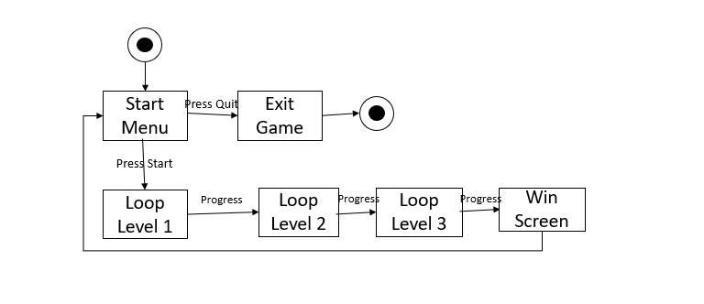
2. 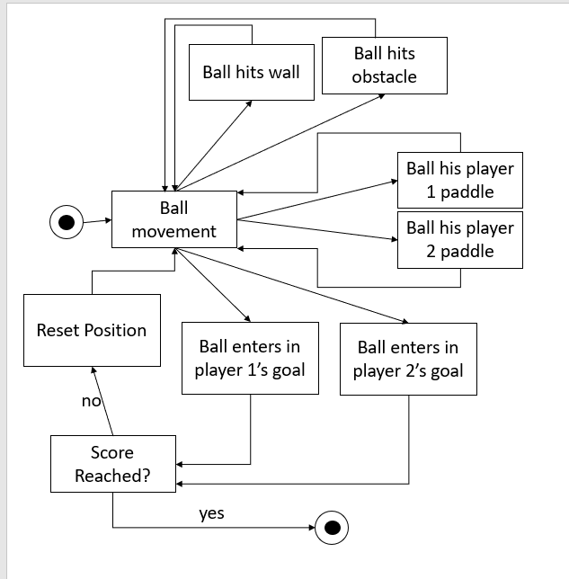

Question 3

Compression must be done to have a well optimized game. Compressing your assets will make the game not only load faster but run faster on slower devices. In a lot of cases your images or audio will have details that would be barely noticeable but affect the performance and loading time significantly. Not compressing your assets will leave you with a very big file as a game. This might also put of users from downloading your game especially if it’s for a mobile device. Depending on what you’re trying to achieve, you might be able to get away with lossless compression.

20mb 4mb

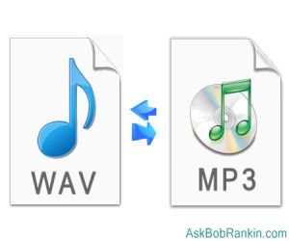

# References

Anon., Ashkan_gc . *Constant Rotation to an Object.* [Online]   
Available at: https://answers.unity.com/questions/52790/constant-rotation-to-an-object.html  
[Accessed 18 12 2017].

Anon., n.d. *How do I move my 2D object using arrow keys ?.* [Online]   
Available at: answers.unity.com  
[Accessed 18 12 2017].

Docs, U., n.d. *Application.LoadLevel.* [Online]   
Available at: https://docs.unity3d.com/ScriptReference/Application.LoadLevel.html  
[Accessed 18 12 2017].

Docs, U., n.d. *Displaying the Score and Text.* [Online]   
Available at: https://unity3d.com/learn/tutorials/projects/roll-ball-tutorial/displaying-score-and-text?playlist=17141  
[Accessed 18 12 2017].

Docs, U., n.d. *Transform.localPosition.* [Online]   
Available at: https://docs.unity3d.com/ScriptReference/Transform-localPosition.html  
[Accessed 18 12 2017].

Docs, U., Unknown. *Bouncing & Sliding in 2D.* [Online]   
Available at: https://unity3d.com/learn/tutorials/topics/2d-game-creation/bouncing-sliding-2d  
[Accessed 2017 12 18].